CHICAGO CRIME ANALYSIS REPORT

EXECUTIVE SUMMARY
Project Overview This report presents an exploratory data analysis of criminal activity in Chicago over the past year. By leveraging Python-based visualization tools, the study identifies critical patterns in timing, geography, and law enforcement outcomes. The goal is to provide actionable insights into how crime fluctuates and where intervention is most needed.
Key Findings
- Temporal Hotspots: Crime is highly concentrated during the summer months and late-night hours (8 PM – Midnight). Heatmap analysis confirms that weekend evenings represent the highest density of incidents, suggesting a strong correlation between social activity and crime.
- The Nature of Violence: A significant portion of violent crimes, specifically Battery and Assault, are flagged as domestic. In contrast, property crimes like Theft and Motor Vehicle Theft are almost entirely non-domestic and occur in public thoroughfares.
- Law Enforcement Efficiency: There is a stark divide in arrest success rates. While proactive policing leads to high arrest rates in Narcotics and Weapons violations, property crimes suffer from extremely low arrest percentages, indicating a difficulty in solving crimes post-occurrence.
- Environmental Factors: The majority of incidents are concentrated in public streets, sidewalks, and residential apartments, with specific geographic Wards bearing a disproportionate amount of the city's total crime volume.
Recommendations
- Dynamic Resource Allocation: Shift police patrols to align with the "high-risk" windows identified on Friday and Saturday nights and during the peak summer season.
- Specialized Intervention: Increase funding for domestic violence social services, as these incidents constitute a major share of Chicago’s violent crime reports.
- Investigative Technology: Improve surveillance and forensic technologies in high-traffic public areas to address the low arrest rates currently associated with property theft and vehicle-related crimes.
Conclusion Chicago's crime landscape is predictable rather than random. By focusing on the intersection of peak times and specific crime types, city officials can transition from a reactive to a more proactive and community-centered safety strategy.

VISUALIZATION
QUESTION 1: What are the most common types of crimes in Chicago? 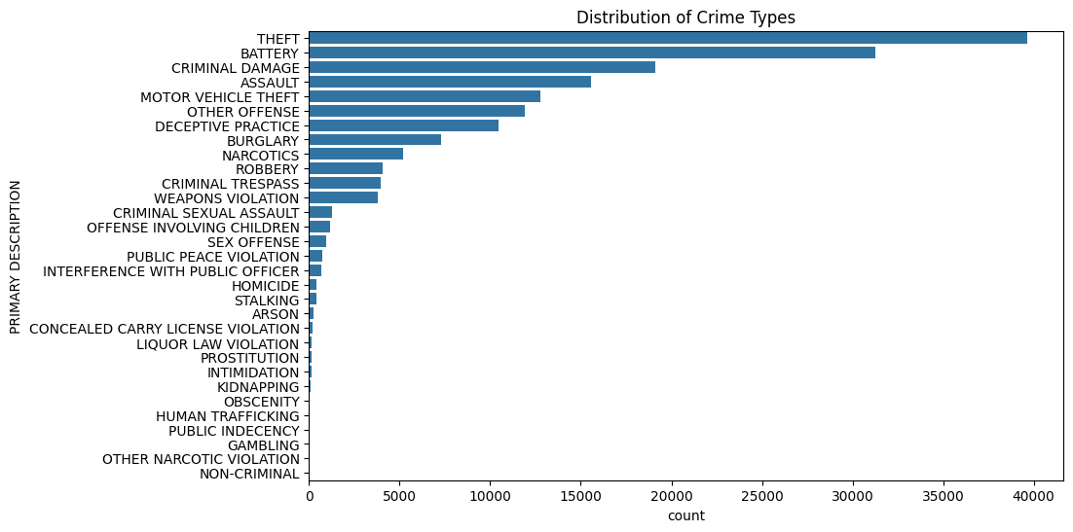
Insight:
- This bar chart establishes the shape of the dataset, showing that property crimes like Theft and Criminal Damage are significantly more frequent than violent crimes.
- It highlights that the city's primary law enforcement challenge, in terms of sheer volume, is managing larceny and property-related offenses rather than narcotics or more severe felonies.
QUESTION 2: What are the most frequently reported types of crime in Chicago, and how is the volume distributed across different categories?
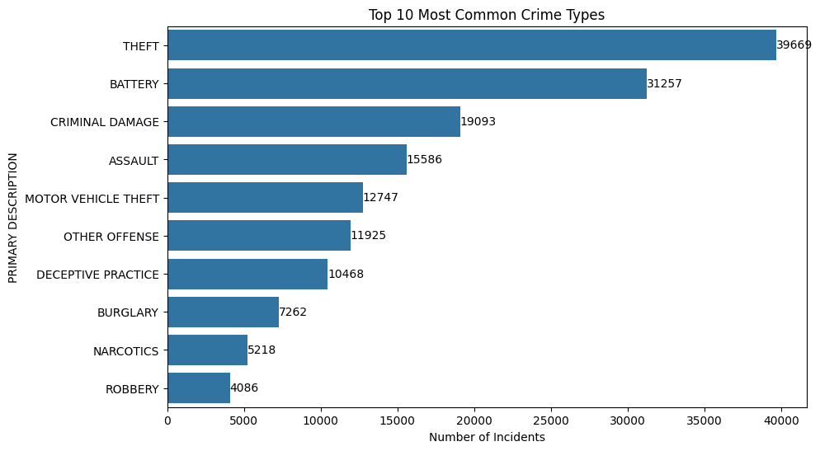

Insight:
Dominance of Property Crime: Theft is the most frequent crime by a wide margin. When combined with Criminal Damage and Motor Vehicle Theft, it becomes clear that the majority of police reports in Chicago are triggered by property-related offenses rather than violent encounters.
QUESTION 3: Which hours experience the highest and lowest number of crime incidents? 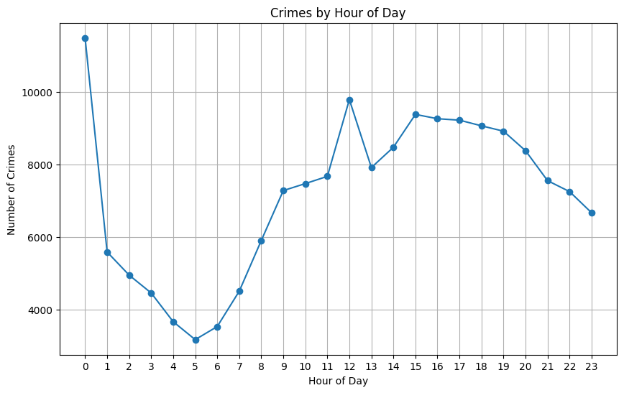
Insight:
- The data reveals a clear "night-owl" pattern where crime volume is at its lowest in the early morning (4 AM – 6 AM) and peaks steadily toward the late evening.
- The sharp increase starting at noon suggests that midday activity and the "after-work" hours are the highest-risk windows for criminal activity, likely due to increased foot traffic and opportunity.
QUESTION 4: How does crime frequency vary across the days of the week? 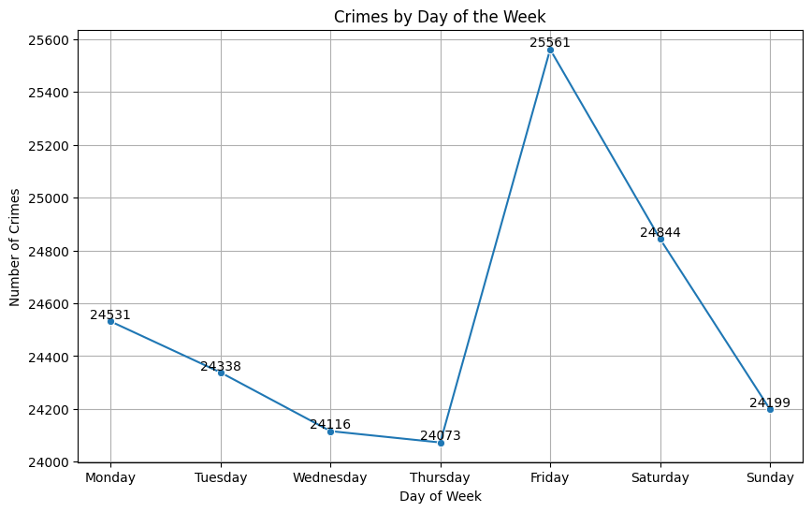

Insight:
- Surprisingly, the distribution across the week is relatively stable, but there is a noticeable uptick on Fridays and Saturdays.
- This suggests that weekend social activity correlates with a rise in incidents, while mid-week days (Tuesday/Wednesday) represent the "troughs" of criminal activity in the city.

QUESTION 5: How does crime volume vary across different months of the year? 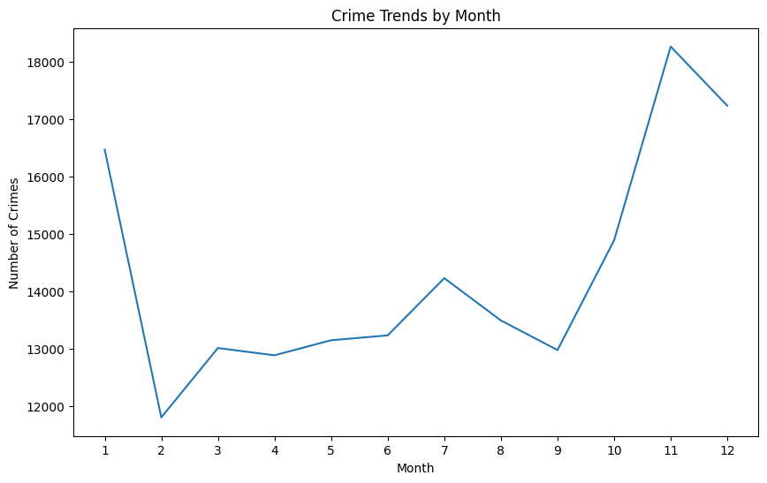Insight:
- This line chart confirms the "seasonal effect" on crime, with a visible peak during the summer months (June–August) and a decline in the winter.
- Higher temperatures and longer daylight hours lead to more people in public spaces, which historically correlates with increased opportunities for both property and violent crimes in Chicago.
QUESTION 6: Which wards or districts experience the highest number of crime incidents?
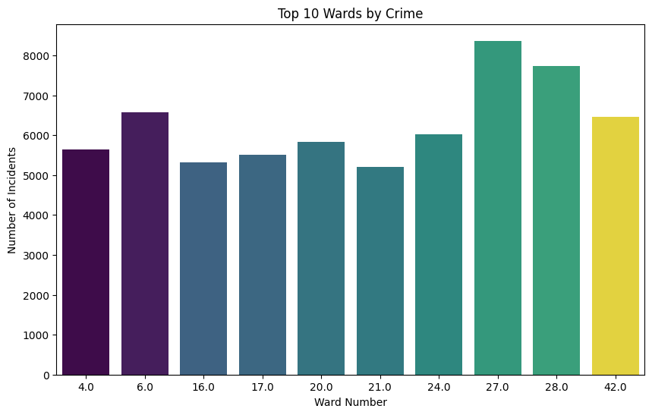

Insight:
- Crime is not evenly distributed across Chicago; certain Wards or Districts show significantly higher counts than others.
- This visualization identifies specific geographic hotspots that require more intensive resource allocation and community intervention programs compared to the quieter residential sectors of the city.
QUESTION 7: How many crime incidents resulted in an arrest compared to those with no arrest? 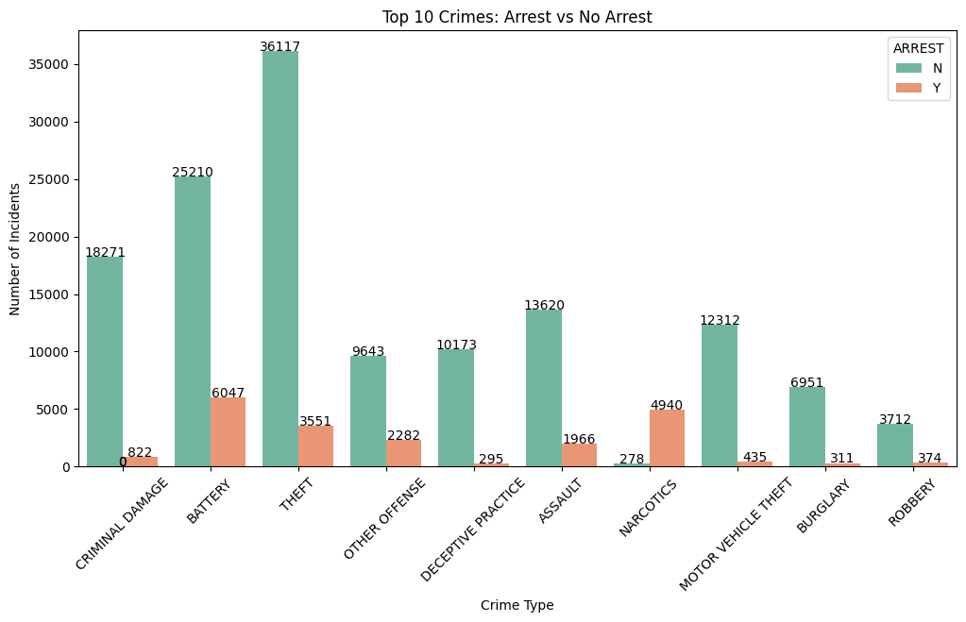
Insight:
This stacked bar chart highlights a concerning "justice gap" where the vast majority of reported crimes do not result in an immediate arrest.
-While some crimes like Narcotics have high arrest volumes, the massive "No Arrest" sections for Theft and Criminal Damage suggest that property crimes are much harder to clear than "on-view" offenses.

QUESTION 8: How do domestic and non-domestic incidents compare in proportion?
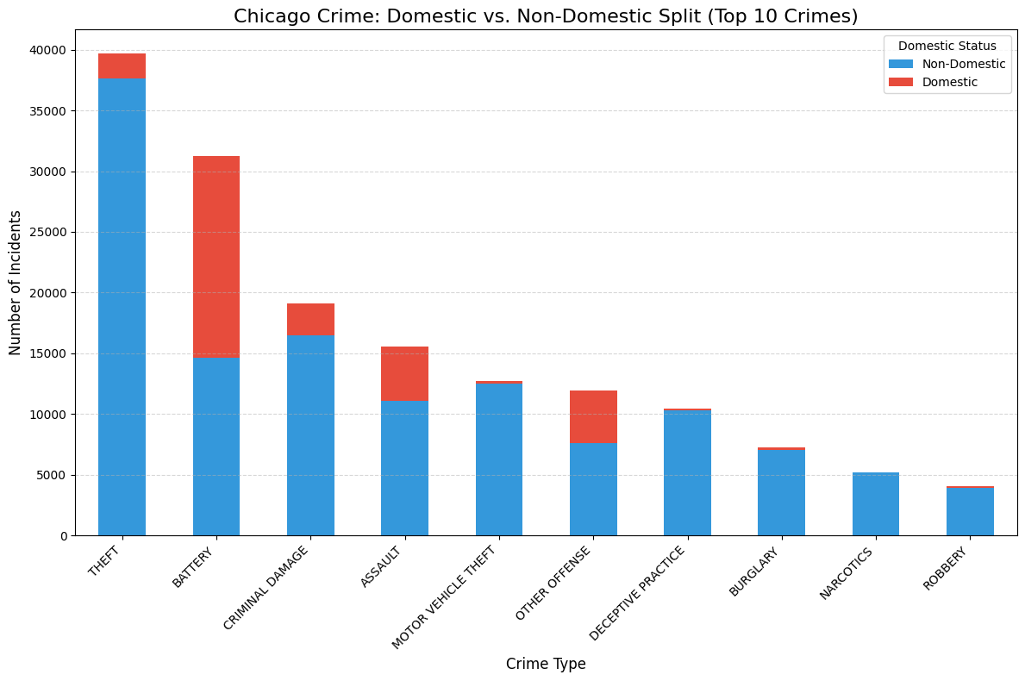
Insight:
- This chart provides critical social context, showing that Battery and Assault have a very high domestic component, occurring between family or household members.
- In contrast, Theft and Motor Vehicle Theft are almost exclusively non-domestic, allowing policymakers to distinguish between "community violence" and "domestic violence" when creating solutions.

QUESTION 9: What is the arrest rate percentage for each crime type?
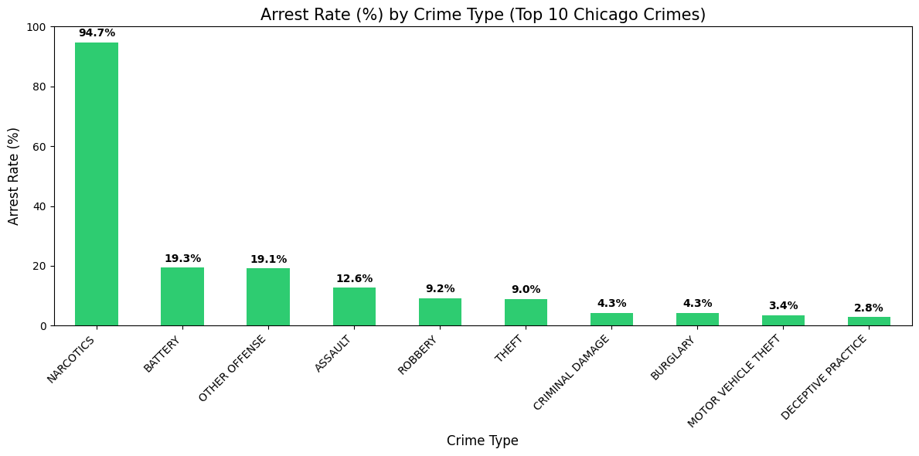Insight:
- This visualization shifts the focus from volume to efficiency, revealing that you are most likely to be arrested for Narcotics or Weapons Violations (often near 100%) and least likely for Theft.
- This tells us that police are highly effective at making arrests when the evidence is found on the person, but struggle with crimes that require follow-up investigation.

Question 10: Which 10 locations report the highest number of crime incidents?

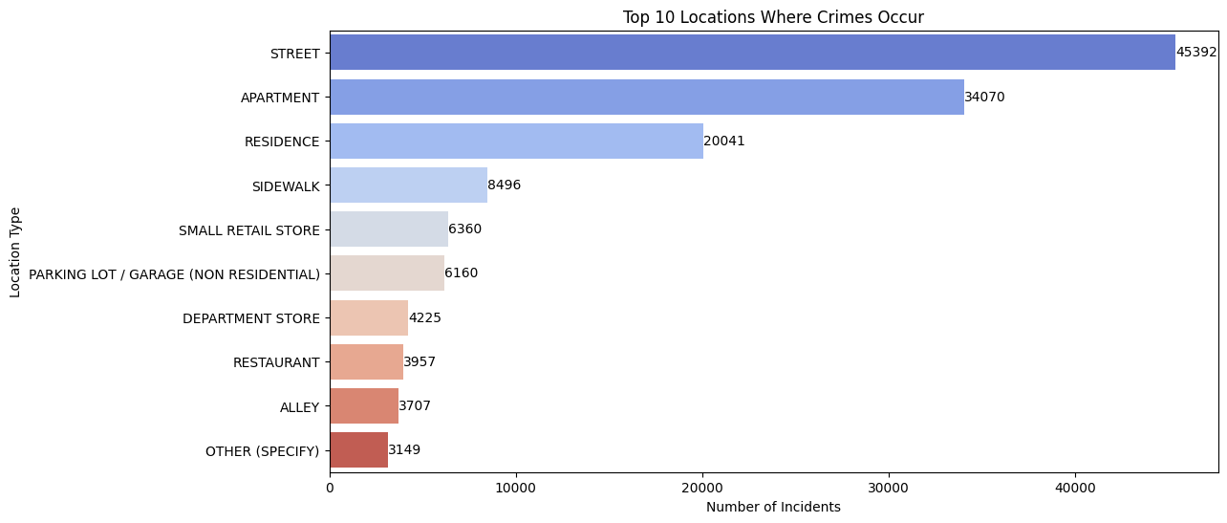

Insight: The data shows a dual concentration of crime in Public Thoroughfares and Private Residences.
- Public High-Traffic Areas: The Street is the most frequent location for crime (over 45,000 incidents), followed by Sidewalks and Alleys. This suggests that a vast majority of Chicago's crime occurs in the public eye, where environmental factors like poor lighting, lack of foot traffic, or limited surveillance may play a role.
- Domestic/Residential Settings: Apartments and Residences combined account for a massive share of the total volume (over 54,000 incidents). This indicates that the home is a primary site for criminal activity—often correlating with the high rates of domestic battery and assault found in previous charts.
- Commercial Targets: Small Retail Stores, Department Stores, and Restaurants also appear in the top 10, likely representing the hubs for retail theft and deceptive practices.
Summary of Main Lessons Learned
Through this exploratory analysis of the Chicago Crime dataset, several key patterns and insights have emerged regarding the safety landscape of the city over the past year:

Predictable Temporal Cycles: Criminal activity is not random; it follows a highly predictable temporal cycle. Crime volume peaks during the summer months, on weekend nights (Friday and Saturday), and during the late-evening hours (8 PM – Midnight). Conversely, the early morning hours (4 AM – 6 AM) and winter months represent the safest periods, suggesting that social activity and weather are major catalysts for crime.

The "Domestic" Nature of Violence: There is a clear divide in the nature of offenses. High-volume property crimes like Theft are almost entirely non-domestic and occur in public spaces. However, violent crimes such as Battery and Assault have a significant domestic component. This indicates that a large portion of the city's violence happens behind closed doors between familiar parties, requiring social intervention strategies that differ from traditional street patrols.

The Reactive Gap in Law Enforcement: A significant disparity exists in arrest efficiency. While Narcotics and Weapons Violations have near 100% arrest rates (likely due to proactive, "on-view" policing), property crimes like Motor Vehicle Theft and Burglary have extremely low arrest percentages. This "reactive gap" suggests that once an offender leaves the scene of a property crime, the likelihood of a successful apprehension drops dramatically.

Geographic and Environmental Concentration: Crime is heavily concentrated in specific "hotspots." Geographically, certain Wards and Districts carry a disproportionate amount of the city's crime load. Environmentally, the Street, Sidewalks, and Residential Buildings are the most frequent settings for incidents, highlighting the need for increased lighting and public surveillance in these specific areas.

Conclusion: To effectively reduce crime in Chicago, the data suggests a two-pronged approach: (1) increased public resource allocation during the "high-density" weekend and summer windows, and (2) a shift in focus toward domestic violence prevention and improved investigative technologies for property crimes where arrest rates are currently lagging.

